4-H Day at the Roundhouse

Tuesday, February 4, 2025

**Santa Fe, NM**

Welcome begins at 9:30 a.m. please be seated and ready before 9:15 a.m.

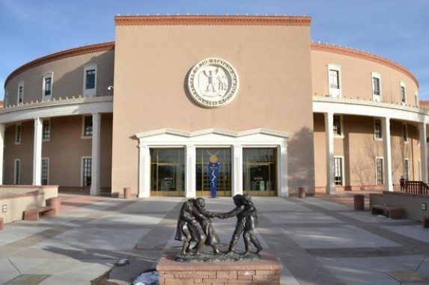



Participation Guide

WHAT IS 4-H DAY AT THE ROUNDHOUSE?

* An opportunity to learn citizenship through active engagement with your state legislators allowing them to hear what **Youth** have to say, before they make decisions about youth programs, education, health, and safety!
* 4-H Day at the Roundhouse is a time for **Youth** to visit with elected representatives in the New Mexico House and Senate.
* An opportunity to share how 4-H impacts New Mexico families and communities through educational programs and services.
* The chance to provide information that congressional members should know about the New Mexico Cooperative Extension Service and the 4-H Youth Development Program.

ROUNDHOUSE DAY TIPS FOR SUCCESS

* Review the agenda and know when and where you are to be.
* Review all provided handouts so that you are prepared to visit with your legislators.
* Research your legislators.
* Be positive.
* Be honest. Answer all questions candidly and as truthfully as possible. If you don’t know an answer, indicate a willingness to find out and get back with the answer. Do not make up an answer.
* Be a strong and articulate advocate for 4-H. This is your chance to speak up for Extension and the 4-H program.
* Thank officials for their support of the Cooperative Extension Service and 4-H.
* Thank the staff and members of the legislature for their time.
* Ask questions if uncertain.
* Remember you are representing and reflecting the attitudes and feelings of your county and state.
* Members should bring one colored copy of their prepared handout “4-H Grows…” with them to registration.

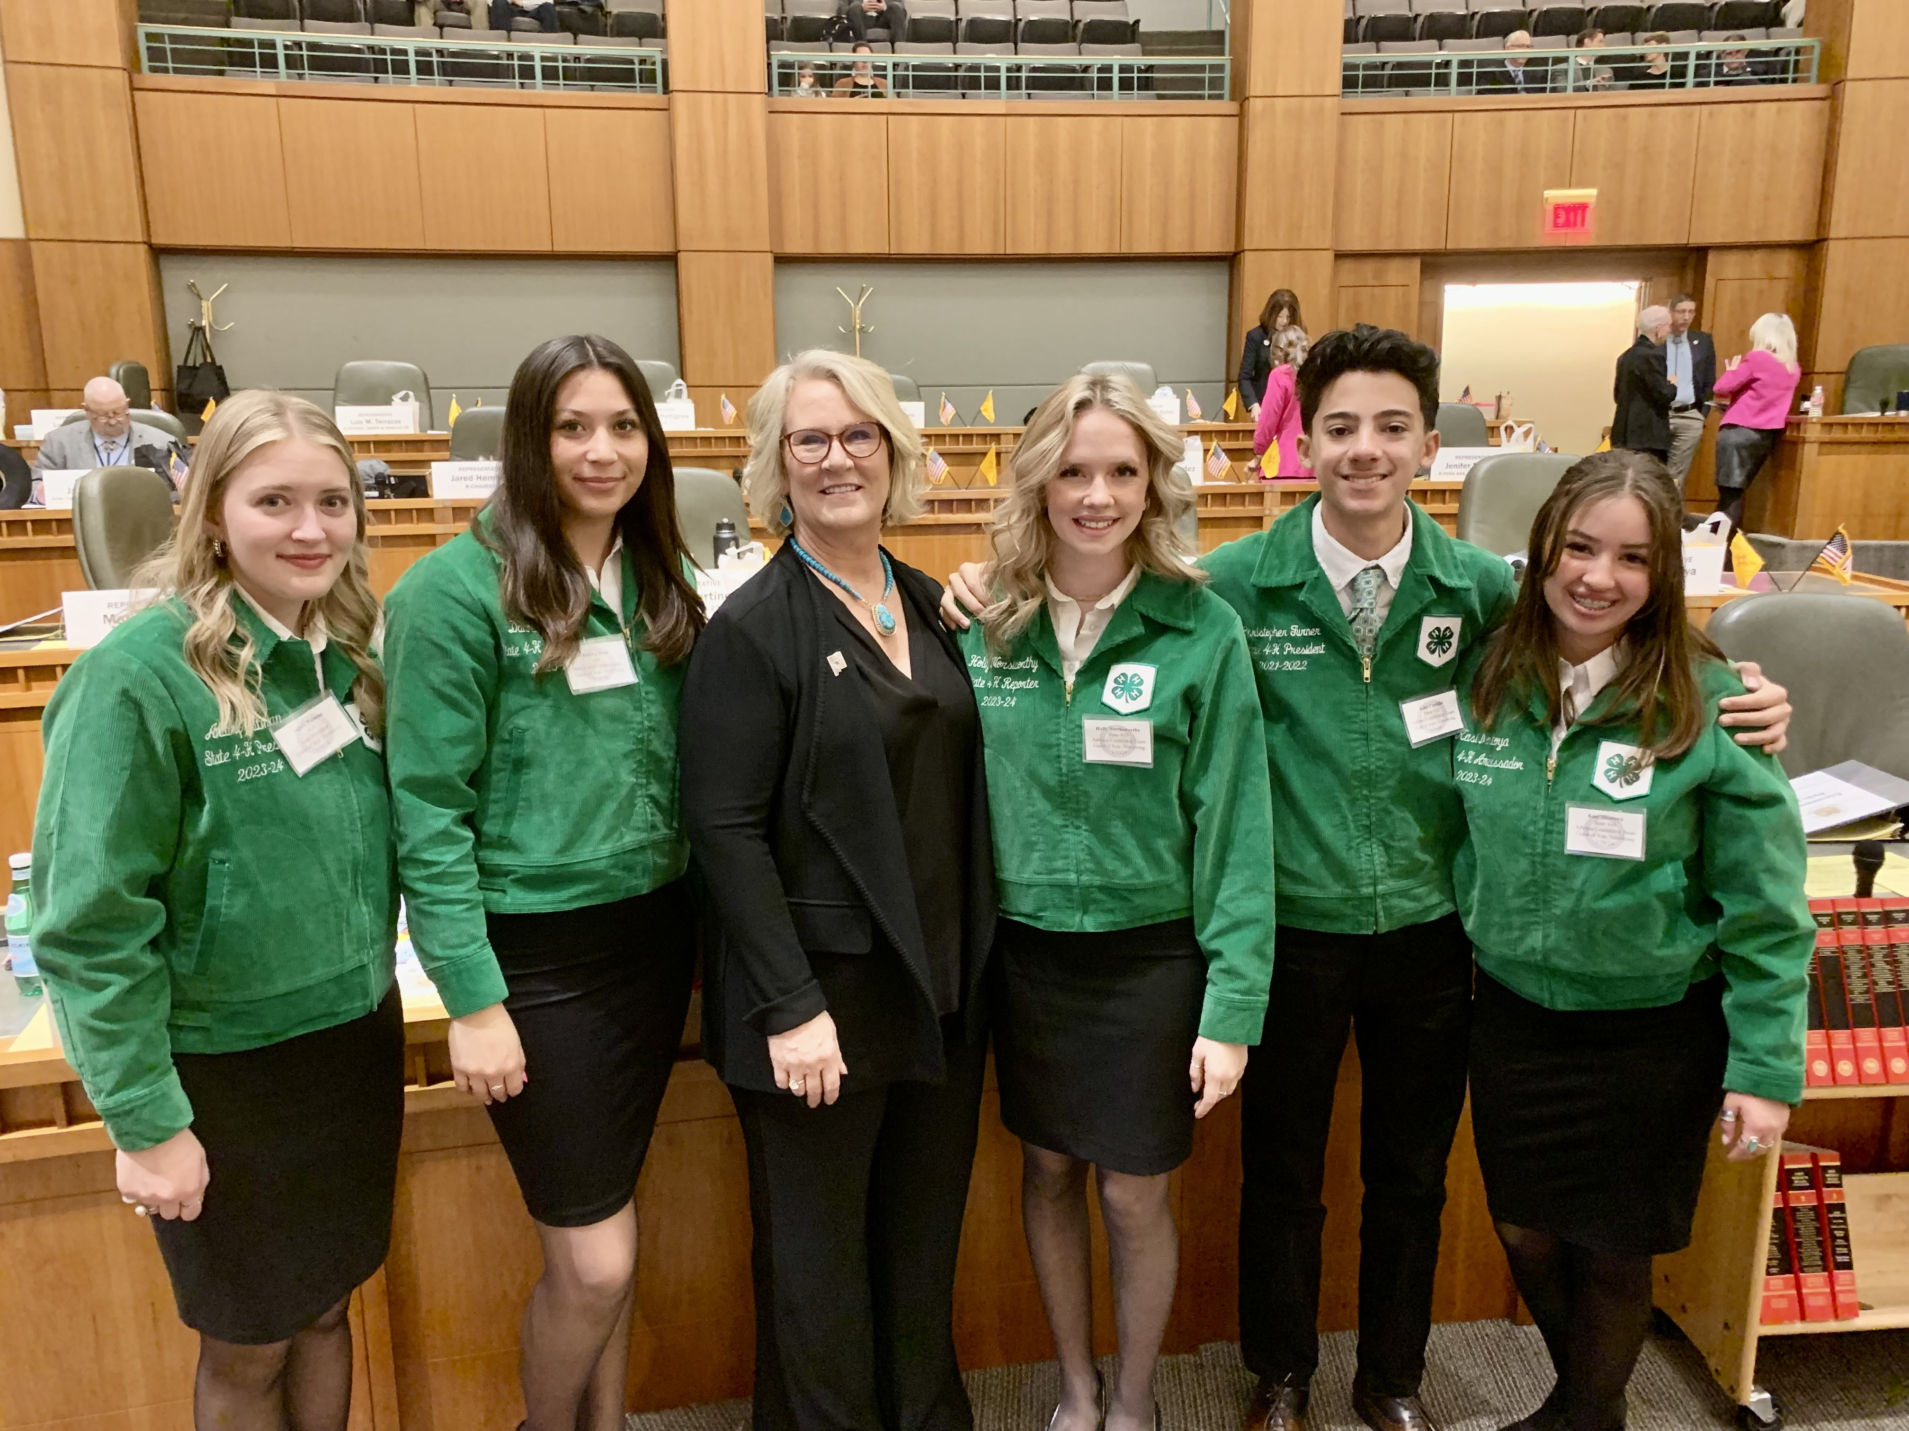

ROUNDHOUSE DAY APPEARANCE AND DRESS

* All delegates and chaperones are expected to be professional while participating in 4-H Day at the Roundhouse. Professionalism includes appearance, etiquette, and presentation.
* Grooming cannot be overemphasized. Good grooming refers to the total package of general cleanliness and neatness—hair, make-up, clean shaven, nails and small professional accessories.
* Clothes should be clean and not in need of repair; free of stain and lint; well pressed/ironed; and shoes clean and polished.
* State Leadership Team members (State Officers and State 4-H Ambassadors) are to wear full dress uniform.
* All other youth and adult representatives will wear dress shirts (4-H polos are appropriate **No T-shirts**) and pants or skirts. Your outfit should be complete with leather shoes or boots and a belt.
* Athletic shoes or hats are not to be worn by Roundhouse Day participants or accompanying adults at any time during the event.
* If wearing a skirt or dress, you should wear hose or tights with a knee length or longer skirt.
* Chaperones are expected to wear business professional dress.
* Wear comfortable and well broken-in professional shoes. You will be on your feet and may have to walk quickly between appointments.

**ROUNDHOUSE DAY CHECKLIST**

* Complete mandatory Roundhouse Day training:

• Watch online session.

• Special Arrangements with your county agent.

* Talk with school officials about getting excused for Roundhouse Day. If you need an absence letter, contact your county agent.
* Do your homework and learn about your legislators.
* Complete the “4-H Grows….” handout and include a photo.

• Have the handout edited by a teacher or Extension Agent.

• Delete wording explaining what to write and box around photo.

• Make color copies for each Legislator you are meeting and bring handouts with you on Roundhouse Day.

* At the conclusion of 4-H Day at the Roundhouse write your legislators and any assistants that helped you a thank you note for their time, interest, and dedication to New Mexico 4-H.

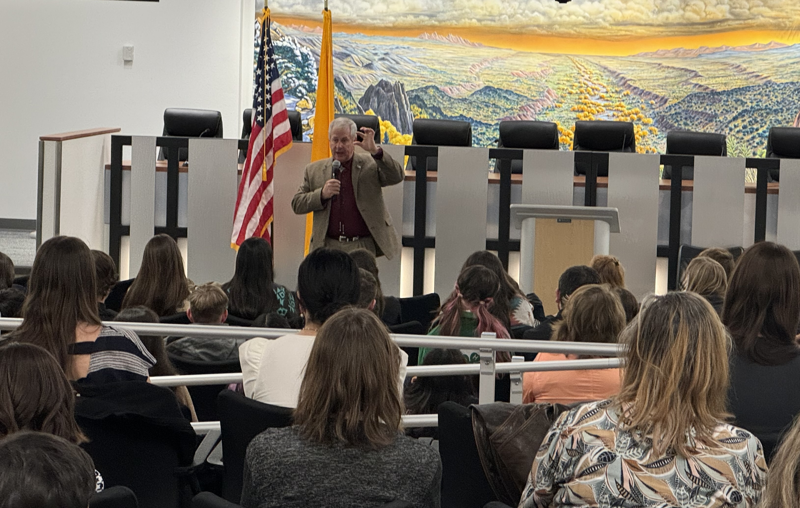

###### Sample Handwritten Thank You Note:

###### 

Dear Senator Smith,

Thank you for taking time from your busy schedule to visit with me during New Mexico 4-H Day at the Roundhouse.

Thank you for your continued support of the New Mexico Cooperative Extension Service’s 4-H Youth Development Programs, who served over 37,000 youth in 2023.

4-H has really helped me learn to make decisions and set goals. I look forward to the learning more about citizenship and other 4-H projects in the years to come.

Sincerely,

**Chris Clover**

Helping Hands 4-H club member

**Cell Phones**

**Things to Know About Your Legislator(s):**

Name and proper pronunciation

What they look like

Political party

Length of service in legislature

4-H or Extension background

Committee assignments

Hometown

Profession

Cell phones will only be allowed for taking photos. Do not be making phone calls or texting during 4-H Day at the Roundhouse.

**Parking at the Roundhouse**

Come early and allow time to find a space and walk if necessary.